Membership Management
The Association manages their members through the a commercial web application called RS!Membership. This is an application that integrates into Joomla which is the platform that the Association website has been developed on. RS!Membership facilitates the online registration, payments, expiry, renewal, and reminders associated with managing membership.
This guide is not aimed at how to use all the functionality associated with RS!Membership but rather give an overview of how it has been set up for use within the Association. However if you wish to gain more detailed information you can visit the Developers website to review the user guides at https://www.rsjoomla.com/support/documentation.html.

Access
There are two distinct interfaces to use and manage the RS!Membership module. There is a Front End and Back End interface. The Front End is where most users will interact with the Membership module. This is where people can register and pay their membership/renewals as well as manage their membership details. The Backend is where the administration and approvals of memberships can be performed as and when required.

Front End Access
This guide will not cover how the Users will complete the registration system as it is generally accepted as self-explanatory. Information on how they can renew their membership can be found here: http://www.wa.raeme.org.au/index.php/membership/membership-renewal
To give the Association some additional functionality and as well as simplify the user interface for general membership enquiry, an additional user interface has been developed. This interface is accessible by going to the association webpage (i.e. wa.raeme.org.au) and logging in. Please note that your Administrator will need to grant you the appropriate site permissions (i.e. User group “Membership Manager”) so that you can use the functionality. From the Membership menu navigate to “Membership Management” as seen below.
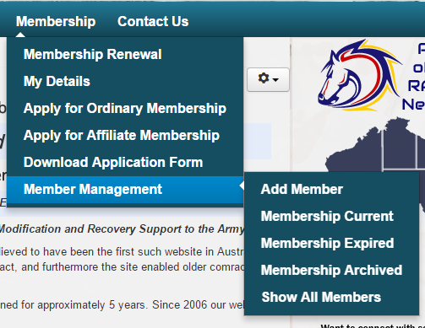
The Membership Management section lists the five additional custom user interfaces that have been developed to aid in membership management. These are:
- Add Member
- Membership Current
- Membership Expired
- Membership Archived
- Show All Members

General Membership Workflow
The rules and approval chain for membership to the association is set out in the Association’s Constitution. The general process for the Membership Module is outlined below.
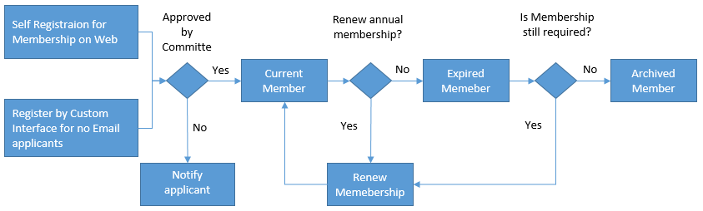

Membership Navigation
The navigation for the Current, Expired, Archived, and Show All Members lists are identical. The forms list the members as per the list specified.
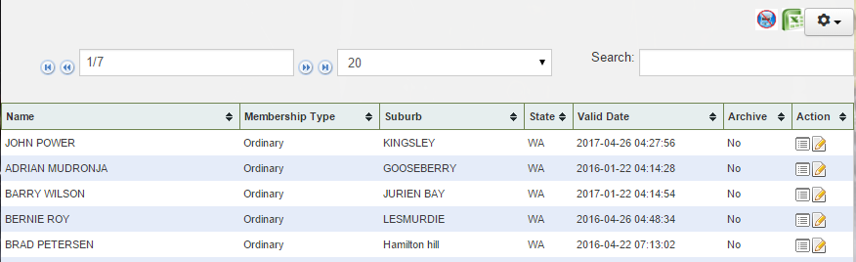
The amount of information displayed can be changed by editing the settings in the drop down list. You can move between pages by using the arrows either side of the page information.
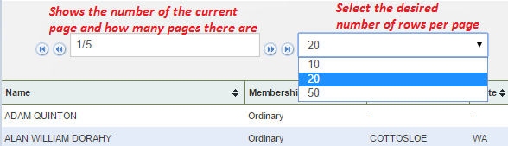
Below is the explanation of the icons displayed.
Exports all members who do not have an email address to Excel.
Exports the list (even if filtered) to Excel.
Will open the selected member’s Membership form in Read Only mode.
Will open the selected member’s Membership form in Edit mode.
 This is only present if you have Administration rights which allow you to modify the display. DO NOT USE THIS UNLESS YOU KNOW WHAT YOU ARE DOING!

Searching for Members
On each page where members are listed there is a search box. Simply start typing part of the name you are looking for and the list will automatically starting filtering to display any name that contains what you have typed.
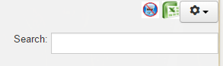

Add Member
The Add Member interface allows the manager the ability to add new members to the Association when paper applications are received which do not have an email address. If the application has an email address it is preferred you use the standard online membership application process as it is more complete and will automatically email receipts to the member.
When adding a member without an email address DO NOT CHANGRE THE DEFAULT EMAIL ADDRESS that is loaded. The reason for this is that for members who do not have email addresses the Secretary will be notified and information that is emailed out to members will be, were appropriate, be posted to the member.
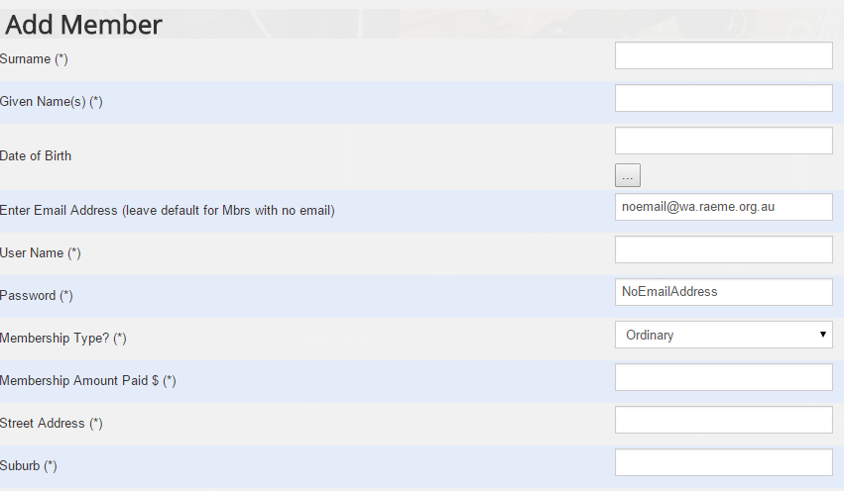

Membership Current
The list displayed shows members whose membership is in date.

Membership Expired
This list shows members whose membership has expired and they have not been “Archived”. The intent is that when a membership has expired a person from the association may contact the member personally to find out why they have chosen not to renew. If the member is non-contactable, deceased or chooses to no longer be a member, the information gathered should be entered into the additional notes field with the date that the member was contacted and their Archived status changed to “Yes”.
Care should be taken when checking expired members. There will be some instances where people may have not renewed correctly and created a new membership. This will result in a record existing in the Current and Expired Member lists. Where this is occurs, make a not in the Additional Notes section and archive the record.

Membership Archived
The list displayed shows members whose membership have been archived. Records can be archived for many reasons. The most common reasons are Deceased, No Longer Contactable, Changed States, or no longer wish to be a member.
To make a member record become archived, enter the reason for making the member Archived in the Additional Notes section and change the Archived status to “True”.
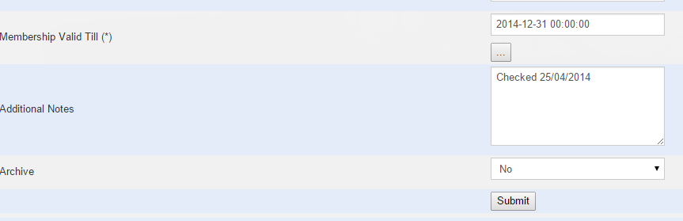

Show All Membership
Lists all members regardless of membership status. All functions relating to membership management can be conducted here without the need to go to the specific membership status areas.

Life Members
Life Members are voted in by the AGM. When a member has been awarded Life Membership their membership type needs to be amended through the custom interface. You need to select the member and choose to edit their membership record. Under membership type select “Life Member”. It is suggested that you also enter the respective AGM dates from when they were awarded the status into the Additional Comments for future reference.
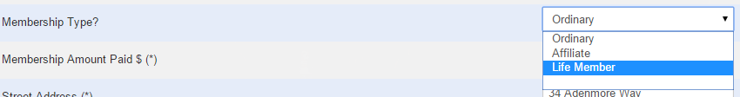
It is very important that the expiry date (Membership Valid to Date) is also set correctly. If the date is not set, they will stop receiving emails. It is suggested that you set the expiry of 50 years into the future.
Ensure you submit the changes.

Renewing Membership
Most renewals should be done by the member on the website. However there will be instances where this does not occur. There are two methods to renew memberships. Method 1 (preferred) is where the membership manager logs into the website emulating the member who wishes to renew their membership. Method 2 is by changing the “Membership Valid to Date” in the custom forms listed above.

Method 1
By renewing membership through emulating the user will automatically send the member a receipt and notification of membership renewal which is preferred.
To log emulate the member the Web Administrator has to grant the Membership Manager access to the plugin “Authentication - Master User”. Once the correct permission has been granted all the manager needs to do is to go to the Association webpage and start the login process. Where th process asks for the User Name enter the user name of the member renewing their membership. In the Password field enter your own (Membership Manager) password and click login. You should see the name of the member who wishes to renew their membership if successful. Once logged in complete the standard online membership renewal process and logout.
Note once complete the transaction will need to be approved pending on the Payment Method selected.
Note: If the user name is not known you can obtain the information by logging into the Backend and selecting Manage from the Users menu and search for their name.
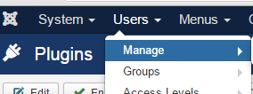

Method 2
Editing the “Membership Valid to Date” for the membership record works to maintain membership however it does not issue any receipts and is the least preferred method.

Backend Access
The backend is specifically for administrative purposes only. It is not for general public access. Access to the back end is controlled by the Web Administrator and you are required to login to gain access. To access the backend you need to navigate to your website and type the “/administrator” at the end of the web URL (i.e. wa.raeme.org.au/administrator) where you will be prompted to login. The same login details you use to login in the front end are used. Pending on what permissions you have will affect what is displayed. To access the Membership Module you need to select RSMembership! from the Components menu as seen below.
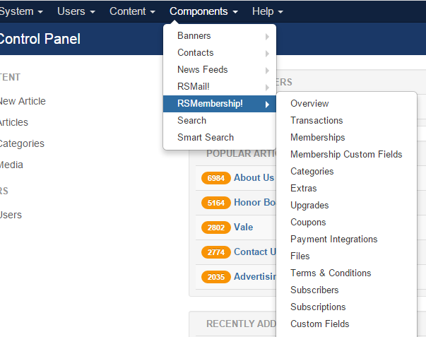
Once selected the Overview console is displayed. As stated previously it is not the intent to explain all the functionality. For this guide we will focus on the Transactions section only.
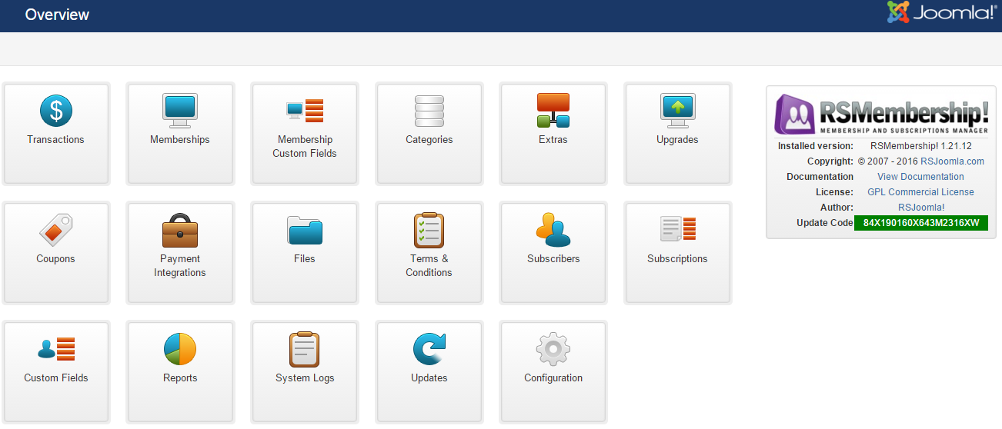

Transactions
The transaction section lists all the transactions relating to New Memberships and Membership Renewals. To view the transaction area click on the Transaction Icon on the Overview screen as displayed above.
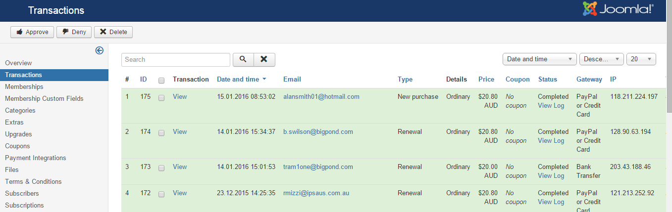
The list displayed shows the Status of each transaction. Once Complete no further action is required. “Pending” will be displayed were the transaction is waiting further action.
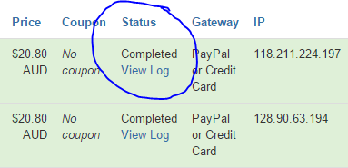
If the Payment method selected is Bank transfer, the transaction will remain as Pending until conformation that the money has been deposited has been received. This can be obtained through the treasurer. PayPal transactions will normally automatically be Approved if confirmation is received by the system. In the event that the confirmation is not received, contact the treasurer to confirm payment has been received in PayPal.
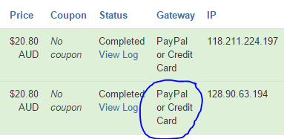
Once payment has been confirmed as received, select the check-box next to the relevant transaction(s) and click on the “Approve” button.
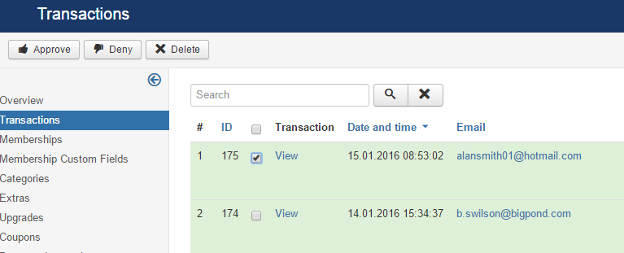
If there are questions relating to the application the membership manage can click on the “View” word in the transaction column. This will display the information as submitted as part of the application.
Once all actions have been complete ensure to logout of the website.

