Joomla - How to Create & Modify Articles – RAEME Websites

General
There are two ways you can create and modify articles on the RAEME Website. These tasks can be performed from either the Front End or the Backend. You will only be able to do this if you have been given appropriate access to your website by the Webmaster.
The Association websites have been developed in Joomla. This is used by thousands of people all over the world and is well supported. It is not the intent of this document to go into too much detail on how to use Joomla, rather its intent is to give you initial guidance to create and maintain articles on the website. If you are interested in know more about Joomla and its extensions, your best place to start is this website https://docs.joomla.org/. Or simply ask “how to do ???? in Joomla?” in Google and you will no doubt get the answer you need. If you get stuck you can email rnst@raeme.org.au and someone will assist.

Joomla - Background
For information, Joomla has two main interfaces. These are often referred to as the Front End and the Backend.

Front End
The Front End is the public interface that people will view the webpages that you develop. Depending on how you set up the content, the user may have to login to view some of your articles. The association current template allows authorised individuals to modify the content from the Front End once they have logged in.
The Front End is accessed by going to you respective association website URL. For example. www.wa.raeme.org.au

Backend
The Backend is the primary administration and web development area of Joomla. This is where users can be added and maintained and controls the complete web development environment. It can only be accessed by authorised people by the use of a User ID and password.
Backend is accessed by going to you respective association website URL and placing “/Administrator” at the end. For example. www.wa.raeme.org.au/administrator

Create Article

Create Article – Front End
The following steps give show how to create an article using the Front End of Joomla. Some of the selections made within the steps may vary slightly for your individual sites. If you have difficulty in getting the steps to work, please contact the National Support Team for assistance.
NOTE: In most forms in Joomla, if you place your mouse cursor over a field title it will display a tool tip which will describe what the field is for and often an example of the content that can be entered.

Step 1
Login to the website by clicking the “Log In” button on your site Home Page.
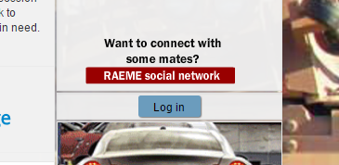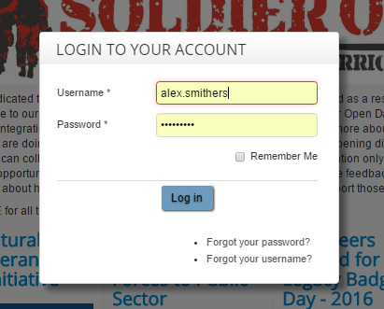
Note: You must be granted permission by your webmaster to login and be allocated the correct permission to create, edit and publish articles.

Step 2
Once you have logged in scroll to the bottom of the page and you should see a second Administration Menu as seen in the image below.
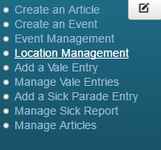
Select “Create Article”. You should then be displayed a blank Article form.
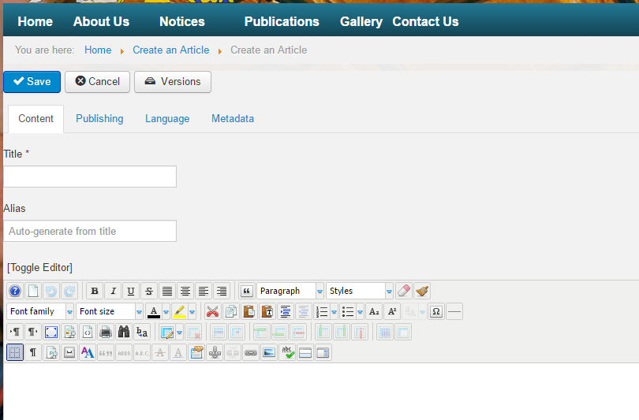

Step 3 – Content Tab
Populate the following fields as required. Anything with an asterisk (*) next to the field name is Mandatory and must be completed. The fields are:
- Title : The name of the Article
- Alias : If left blank, it will be auto populated on Save. It is an internal name that is used by web URLs. No spaces will be in the name and it must be unique for all articles.
The “[Toggle Editor]” will change the content view below it into HTML of WYSIWYG (What You See Is What You Get) which gives you buttons to perform tasks like those in Microsoft Word.
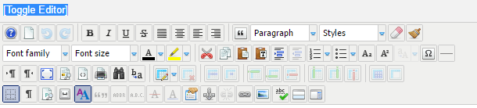
In the area below the buttons is where you write your article. You write it like you would normally write a Word Document. The three features you are likely to use are the “Insert/Edit Link”, “Insert Image” and “Insert Read More”.

Insert / Edit Link
The link allows someone to click on text or an object and it will take the user to a different location. To insert a link (Hyperlink), select the item text/image and click on the icon.
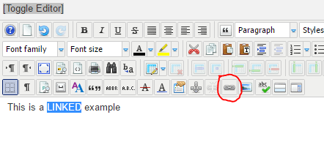
Once you have click the button, a form is displayed to allow you to enter the required information as seen below. You can either enter the URL that you want the link to take you to in the URL field (usually to an external website. For example” www.google.com.au”) or you search and select from within the website if you want to link to another page from your site.
The “Target” field is very important. It tells the page how to respond when the link is clicked on. If nothing is selected the current page will be changed to the URL you entered. This will take you away from your site. Usually you will choose “Open in New Window”. This will open a new tab to the linked page.
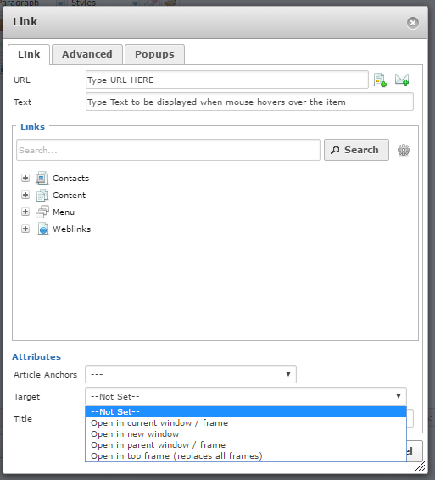
The “Text” field should have a user friendly name that indicates what the link will take them too. Using the example above “Search Google”.
Once you have completed the required information click in the Insert button to append the link.

Insert Image
This will allow you to insert an image into your article. You will be able to choose an image that has already been loaded on your site or you could upload a new image if required. If you choose to upload an image for an article be mindful of the image file size! Your image size you not be any bigger than 300kb in size. The larger the image the longer it takes to load and more data it consumes when someone views it! This is very important as we have a lot of people view our pages through Mobile Phones. If it takes too long to load they won’t look at it… it also it is expensive to view on phone data plans.
Select the place in the article you want to insert the image and click on the Insert Image Icon as circle in the image below.
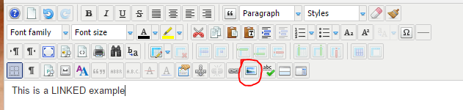
Once you click on the button a form is displayed that allows you to either select an existing image from your site by using the file browser section or upload a new image.
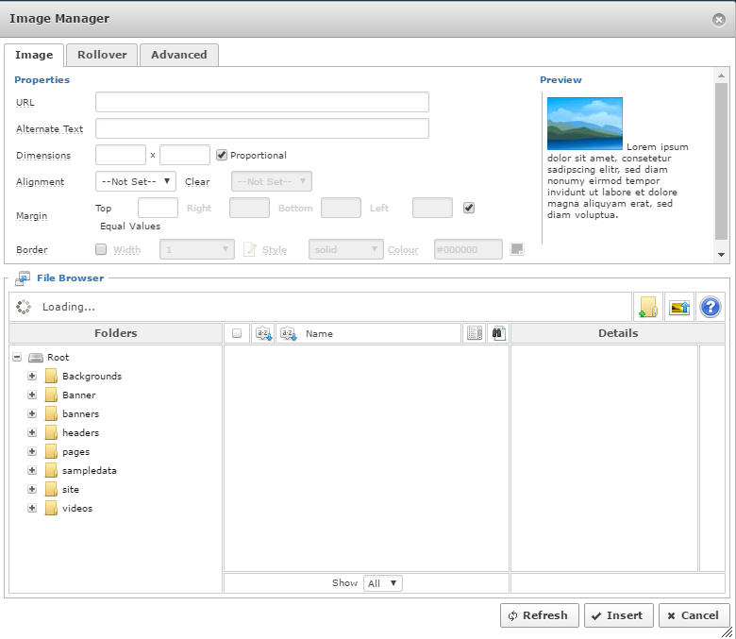
To upload a new image (NOTE previous warning about image file size!), click on the image upload icon. This will display an additional form that will allow you to browse and select the image from your computer to upload.
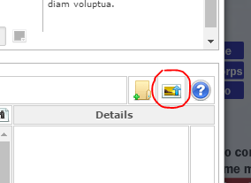

Once you have navigated to and selected the image on your computer, click on the “Upload” button to load the image to your site. Once uploaded, the image will appear in the list. Click once on the image to select it.
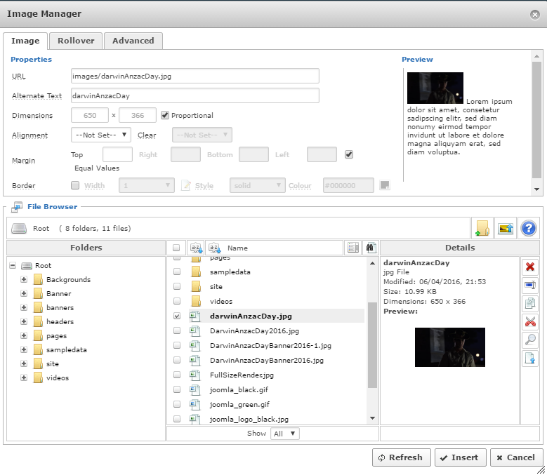
The URL and Alternate Text fields at the top of the form should be populated with the information pertaining to your image. You can change the Alternate Text” to read a user friendly name of the image which will be displayed when the mouse is placed over the image.
Once you have completed the required information click on the “Insert” button and the image will now appear in the article.

Insert Read More
The Insert Read More option allows a snippet of the Article to be displayed with a button to click to read the full article. The home pages have been set to display in a Blog Layout. This will show multiple articles for specific category. The intent is to only show a snippet to entice the reader.

The way to use this option is to enter the text and images as required that you would like to initially display as an article introduction. Enter a new line in the content page and click on the “Insert Read More” icon. Then enter the full article after the separator. This is often the same as the introduction but continues until the article is completed. An example can be seen below.
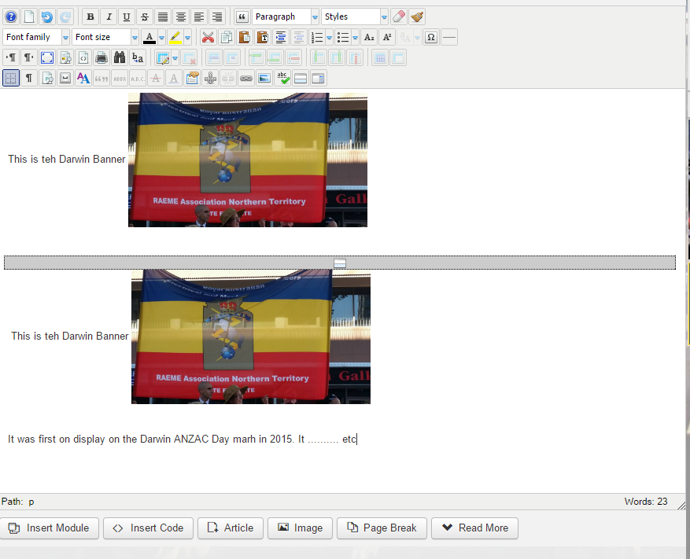

General Notes About Article Content
There are numerous other options available on the formatting pallet for creating article content. A lot of the options are fairly standard (Insert a table, bold text, Italics, etc.). You can experiment with these options to get the article to be displayed as desired. However, there are a couple factors you need to keep in mind when developing the article content. These are:
- Colours – There are people who are colour blind. So be mindful of the colours you choose. Pure Reds, Greens and Blues should be used carefully. A section of text in red may not been seen by a colour blind person.
- Font Size – Too small font should be avoided.
- Content – Should be appropriate (no naked photos for example)
- Email Addresses – Avoid inserting email addresses in articles. Web crawler (software that automatically reads web content) will browse the site and collect the email addresses and they will start to receive a considerable amount of Spam emails. It is requested that you Do Not Include any of our domain emails in the article (ie. president@wa.raeme.org.au or secretary@qld.raeme.org.au). These, if seen, will be removed from the article by the National Support Team. The reason for this is that it increases Spam emails as previously stated, it also puts more load on the email server which slows the system. It also encourages spammers to attach the server to send emails under our email addresses.
- Images – Image file size; keep them small!
- Check how the article will look on a mobile device – The website is designed to be mobile friendly. Images will be resized and text wrapped so that it can be displayed efficiently on small screens. Once you have created your article, open the article in your browser and resize the width of the browser by clicking and holding the side frame of the browser screen and dragging it across to narrow the width of the screen. If the article does not resize to fit you may have to make changes so it works correctly. Again, if you get stuck, contact the National Support team and they will try to assist.

Step 4 – Publishing
Click on the Publishing Tab of the Article. The publishing tab give a series of options that affect if, where and when an article is displayed.
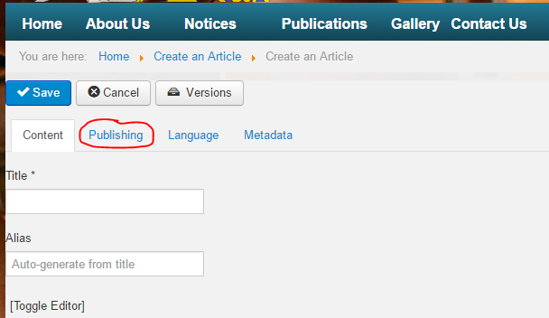
The key fields on this tab are:
- Category – The Category is what the article is associated with. Pending on your site, the content in the drop down list will vary. The Home page on most sites have a Blog page that will display articled that are associated to one category. In most instance you will choose a category like “News Article”.
NOTE: If the article does not display on the expected page, it is usually due to this category being incorrect!
- Status – The drop down list provided is fairly self-explanatory. Select Publish to have the article displayed.
- Access – Generally this is set to Public which lets anybody view the content. To limit specific people to view the article, select the desired group you want to limit the article viewing to.
There are other options which you can set as desired. The tool tip (hover mouse over field title) will explain these functions.

Step 5 – Metadata
Click on the Metadata Tab of the Article. The metadata tab displays two fields that should be populated. Although these fields are not mandatory, it is strongly recommended that they are populated. These fields are used by search engines. By placing text in these fields it increases the likelihood that when someone searches for specific information, your article will be returned in the search results.

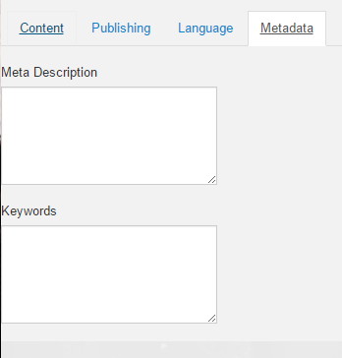

The Meta Description is a brief synopsis of the article. It is the text that will be displayed under title of the search results.
The Keyword are a series of words, separated by commas (,) that help identify the article. For example, if you had an article about the RAEME in the 2016 ANZAC Day march in Melbourne, you could use the following key words to describe it: ANZAC Day, Melbourne, 2016, RAEME. If someone typed those key word in any order into a web search engine (ie. Google) there is a higher probability that your page will be displayed.
NOTE: It can days to weeks for search engine crawlers to recheck the site. It is not until the site has been re-crawled will the search results be updated. It is not instantaneous!

Step 6 – Save the Article
Once you have made all the changes required, click on the “Save” Button at the top of the form. This will save the article and make it available as per the publishing settings entered.
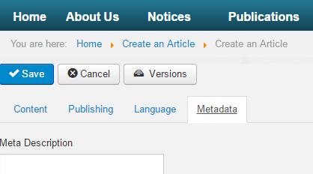
When you click the “Save” button, the page will close and take you back to the Home page. If you have not made all the required changes you will have to navigate to the article and from the Cog icon select “Edit” and continue to make the changes as required.

Article Search
If you have not set the Article Category correctly the article will not be displayed in the correct location. You will need to locate the article to correct the article. By default, articles are allocated to “Uncategorised”. To locate the article, click on the “Manage Articles” from the menu at the bottom of the page.
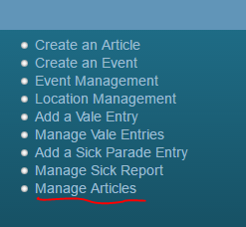
This will display a list of all the articles that have been created. Browse the list and select the article you need to edit.
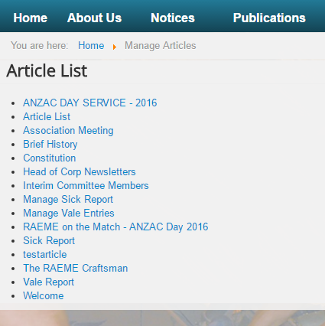

Edit Articles – Front End
To edit an article, navigate to the article (either by normal page viewing or the Article List via the Manage Articles menu). Click on the cog image and select “Edit”
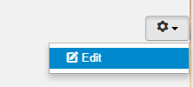
This will take you to the same screens used to originally to create the article so that you can make the required changes. One done, click “Save” to commit the changes.

Create Article –Backend
The process of creating the article is the same as the front end only the means to navigate to the article and create article option are different.

Step 1
Navigate to your Administration page by placing “/Administrator” at the end of your association website (for example. www.wa.raeme.org.au/administrator) and login.
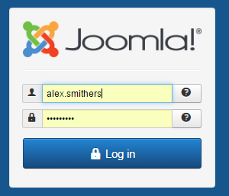

Step 2
Once you have logged in, navigate to Article Management by clicking on Content then Articles.
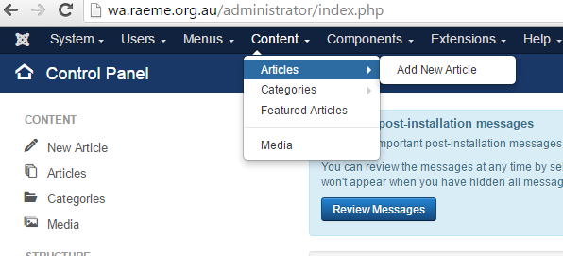
This will display the Article Management page where you can create, edit and delete articles.
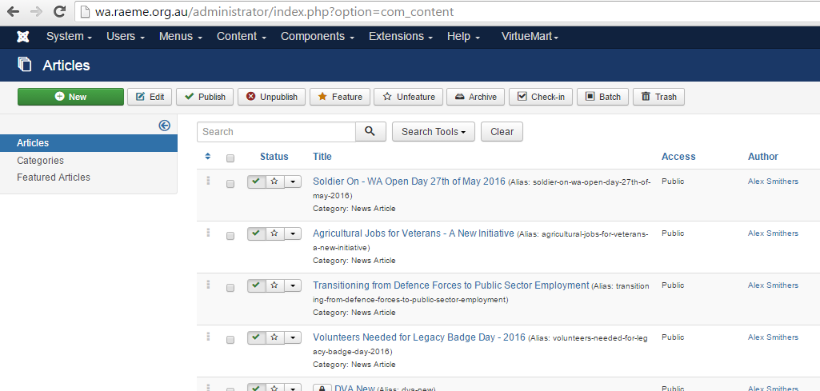
You can search for any article by typing part of the article title into the search field and click on the magnify glass icon.

Step 3
To edit the article, simply click the desired article title and the article will be opened in edit mode. Make changes as required and click save.

Once you have completed all the changes, Log Off from the backend and navigate to the general public interface (Front End) to view the changes you have made.
To create a new article, simply click on the “New” Button and follow the same steps as performed from the front end. Note there are more options available from the back end which have not been spoken about in this guide. You can search the internet for more information on these options if desired.

Summary
The process of creating an article is fairly straight forward. There is a lot of functions that are available to you when you create an article which have not been discussed. You are encouraged to experiment with additional functionality as it is very difficult to break the system. If you are having difficulty or would like some additional advice please email rnst@raeme.org.au and someone will try and assist.

