ANZAC Day Tasmania 2026
Well the weather gods delivered a perfect winter’s day over our state this year. ANZAC Day was commemorated in true RAT style with events and activities held in Hobart, Launceston and StHelens.
In Hobart members after attending numerous Dawn Services assembled at Customs Hotel for customary pre-drinks before attending the 1100h service under what could be best described as very warm conditions, most unusual for this time of year in Tasmania. One highlight, two members were interviewed by 7 News during the course of the march which was featured on 7 News Saturday night.
Following the service members and friends assembled at the Hobart Worker (RSL) club for lunch and a chance to reconnect with old mates not only our brethren friends but other corp members where stories and memories of times gone by continued.
To finish of the day, some members continued on to the Anglesea Barracks Sergeants Mess to participate in two up games and continue reconnecting with old mates.
All in all, another fantastic afternoon enjoyed by everyone.
The following selection of photos showing members and friends, young and old, supporting and enjoying time with mates, family and family friends at our regional marches, after-march events and get-togethers, including the ever popular two up games. More photos can be seen on our website via the following link
https://tas.raeme.org.au/index.php/gallery/anzac-day-new/view-album/tag-Anzac%202026
 | 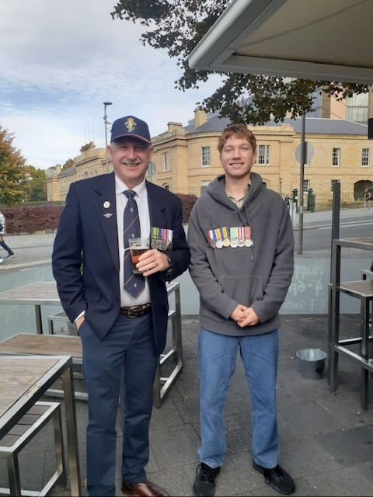
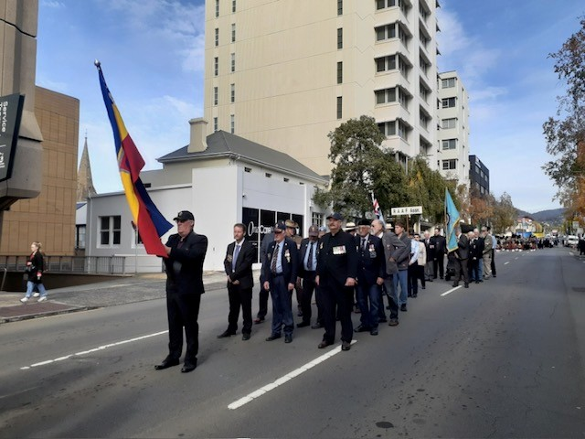 | 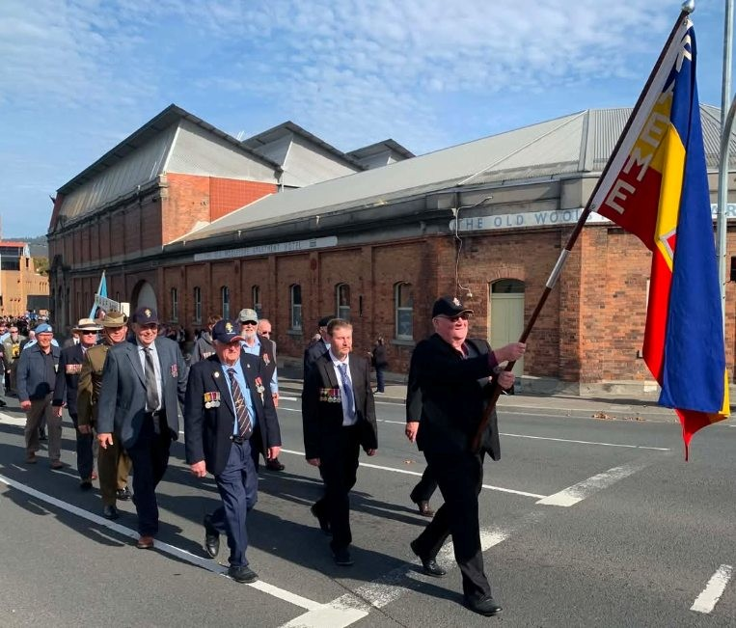
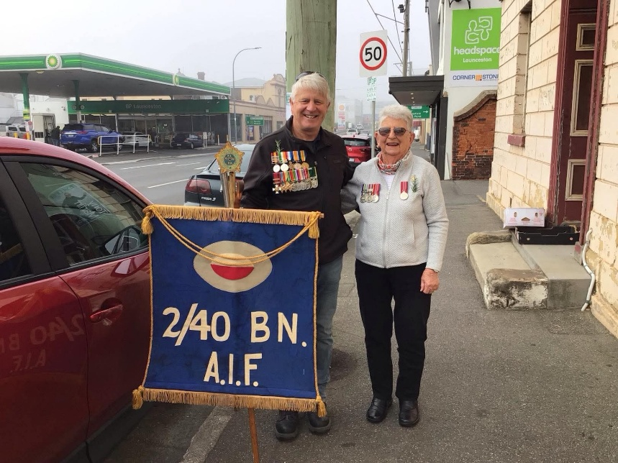 | 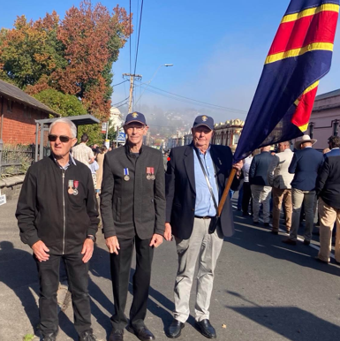
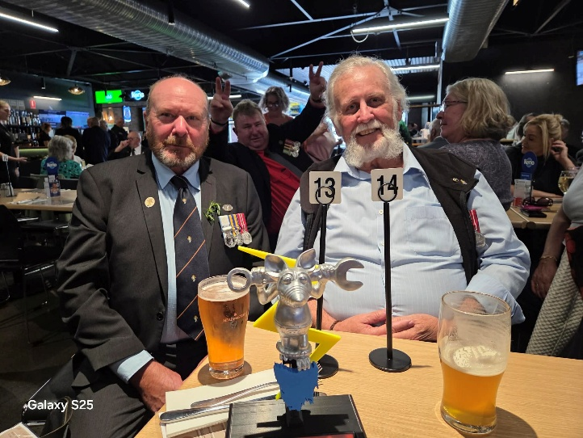 | 

