9th Annual RAEME Get Together 20/2 - 22/2 2026 Bjelke-Petersen Dam

Or RAEME in the Field, but not as you know it…
The weekend of 20-22 Feb 26 saw the Annual RAEME Get Together take place at Bjelke-Peterson Dam at Moffatdale SE Qld. From a small group in 2018, this year saw 144 past and present Corps members along with their partners gather at the Bjelke-Petersen Dam Caravan and Recreation Park. Thanks yet again to Heath & Rowena for looking after us with discounted accommodation over the weekend.
Friday afternoon’s “Happy Hour” saw Greg Riley welcomed everyone to the weekend, followed by Karen Cairns & Helen Neeson, this year’s “Mistresses of Ceremony” (MC’s) briefing everyone on the planned activities over the weekend. Friday night’s entertainer, John Lindsay, who apart from keeping everyone entertained till “Bedtime”, brought everyone to a literal standstill at sunset, as he played a stirring rendition of the “Last Post” on his guitar followed by the Ode recited by Greg Riley. The “A” Team fed the masses via a snag sizzle, ably led by Karen & Helen with a great support team of, Lynette, Julie, Easy & Shane. As the crowd dwindled, most saving themselves for a ‘Big One’ tomorrow night, some of the more adventurous participants stayed on to relive past recoveries, convoy trips, exercises, and assorted shenanigans into the small hours of Saturday morning.
Saturday afternoon saw Jackie Gillam giving a brief on the planned changes by DVA to the VEA, DRCA & MRCA, to those that were interested or may be affected by the changes. An informative session that had a lot of people a lot less stressed after the briefing. This was followed by the MC’s hosting an hilarious and entertaining Trivia competition with the questions delivered in a manner that only a qualified RI could deliver. The trivia comp then rolled on into the Charity Auction.
The auction is run to raise a few dollars that are then gifted to the Murgon Hospital Auxiliary in appreciation of the support we get from the local community each year, from the loan of a cold room from Murgon APEX, discounted accommodation from the van park for the weekend, Friday night’s entertainment supplied by the South Burnett Council. By choosing the hospital auxiliary, it is a cause that aids the entire local community. Our master auctioneer Michael ‘Wilko” Wilkinson, assisted by ‘spotter’ Karl Kuzmenko with ‘super model’ Clarrie Sanders in support. This is held in conjunction with yet another “Happy Hour”, considering how long these last, they are the worst named event of the entire weekend. However, a few refreshing beverages seemed to relax the grip everyone had on their purse strings, and some phenomenal prices were realised for some of the rarer auction items. It was then up to Cheryl Clegg and Perry Belford to host "Saturday Night Live" AKA "Karaoke night" AKA the "RAEME Rock Show" well supported by Wilko as stand-in sound engineer. There was plenty of talent and thankfully only the rare case of no talent on display. From ABBA through to ZZ Top, the crowd was kept singing along till we hit the park’s noise curfew. Unable to attend this year’s event, Terry ‘Sandals’ Johnson delivered his stirring version of ‘The Band Played Waltzing Matilda’ in the best of RAEME ‘Just make it work’ traditions, sung on the Sunny Coast, delivered by data link to BP Dam, played over a phone into a mic through the sound system and enjoyed by all. A special thanks to Graham ‘Ernie’ Earnshaw and the Bray Park Strathpine RSL for the use of their professional sound system for the night. Again, some people played harder than others and were keeping the fire pit stoked and telling yarns, some of which I suspect were even true well into Sunday morning.
Sunday kicked off with a sausage sizzle for breakfast, held in conjunction with the “Crafty Markets” with all manner of goodies made by the crafty ladies and some of the crafty crafties on offer. We then gathered on the ‘Grassy Knoll’ to draw the raffle, the major prize being a RAEME themed rug, hand made by Pam Beal, a brief on next year’s gathering, the group photo and the presentation of the funds raised over the weekend to Muriel Shultz, the President of the Murgon Hospital Auxiliary. Shane ‘Easy’ Rider won the raffle but since it was his sister that made the rug, taking it home wasn’t an option, and it was gifted to Wendy Dowling. This year the event raised $5,223.25, this was a surprising amount, firstly because it is easily the highest amount we have ever raised since we started fund raising and brought the cumulative amount donated to close to $20K, and secondly, everything was sold in whole dollar amounts, but we still ended up with $0.25.
The planning for next year’s event is well underway, and thanks to an extremely generous donation by Darren ‘Monty’ Moncrieff through his company Pacific Direct, it is already shaping up to be a huge gathering surpassing everything that has gone before.
If you would like more info or to get involved, head to RAEME 10th Annual Get Together 26/2 - 28/2 2027 Bjelke-Petersen Dam | Facebook answer the membership questions and follow along.
Arte Et Marte
Clarrie SANDERS
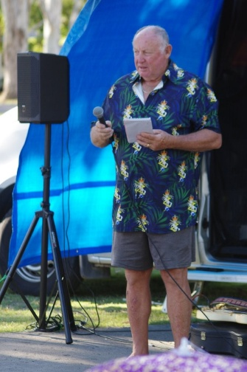Greg Riley welcome brief.
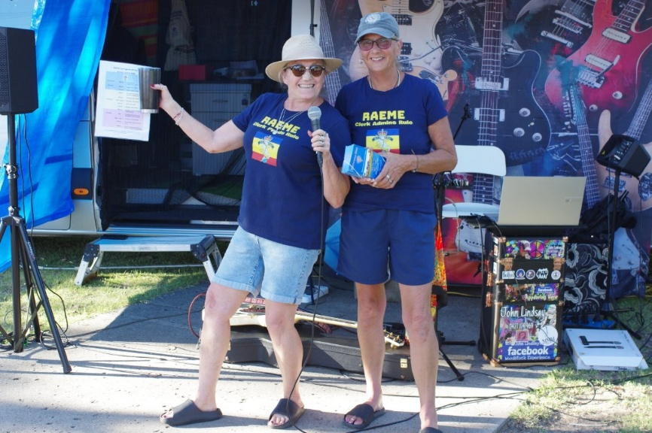
Karen & Helen, our Mistresses of Ceremony for the weekend.
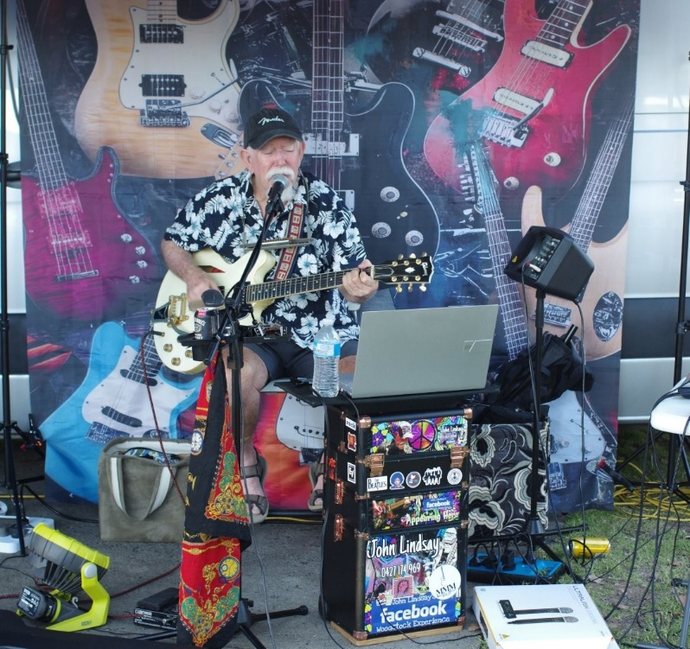
Friday Night’s entertainer, John Lindsay.
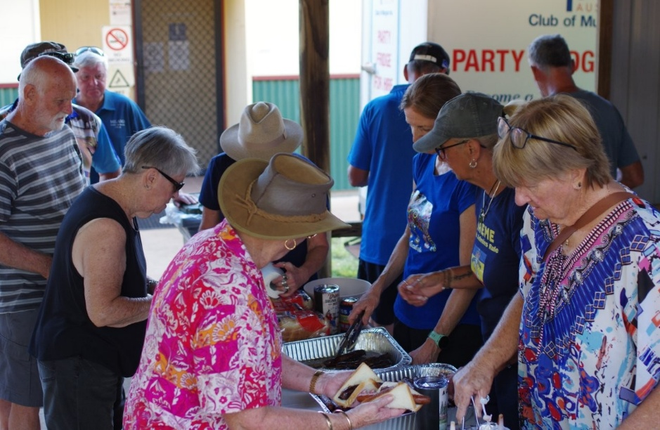
The ‘A’ Team feeding the masses.
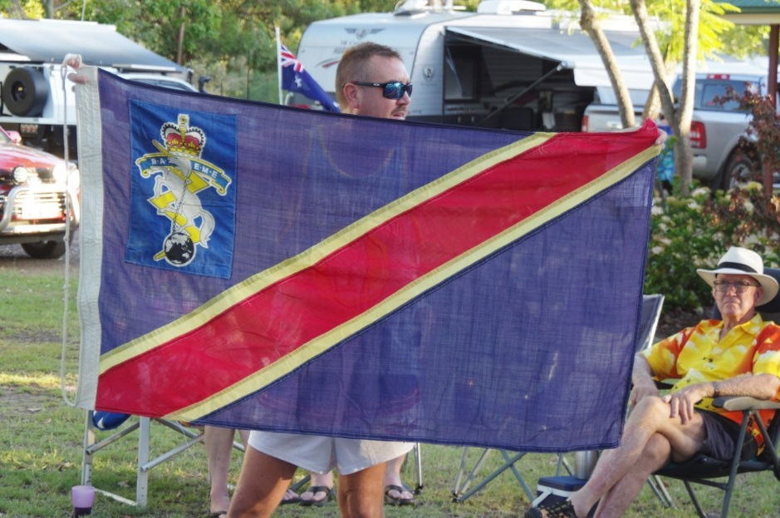
The last flag to fly over RTC, an auction record price paid.
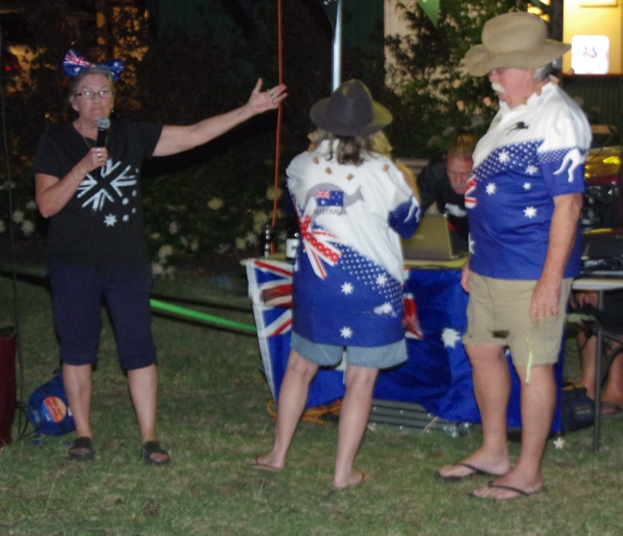
Judging the “Best Aussie” costume.
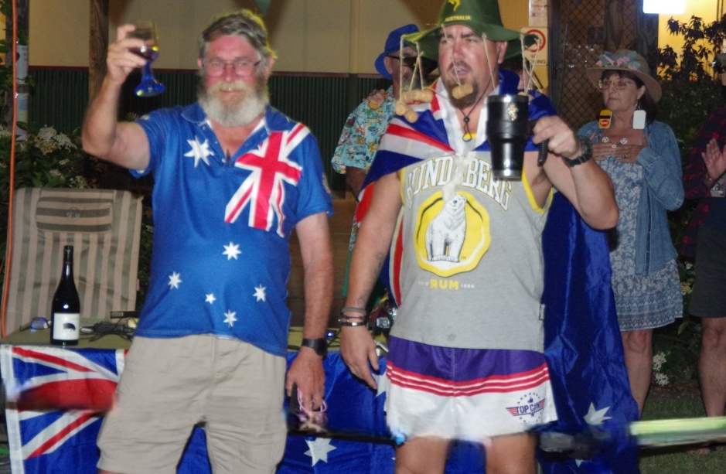
Judging the “Best Aussie” costume.
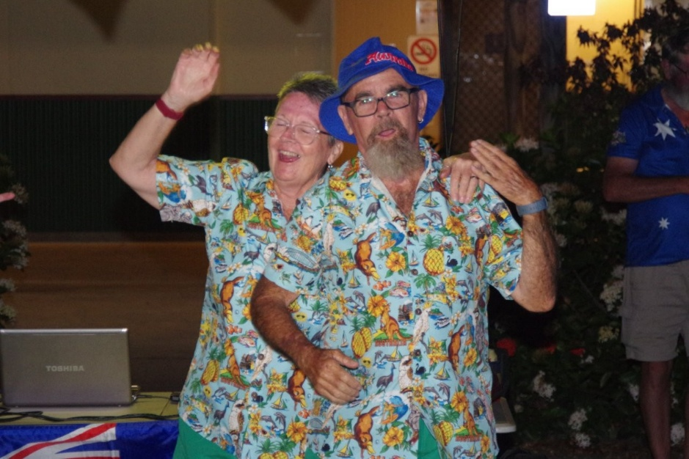
Judging the “Best Aussie” costume.
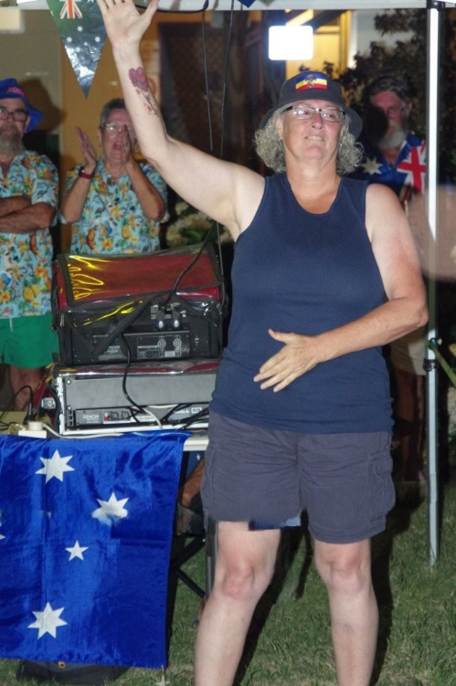
Judging the “Best Aussie” costume.
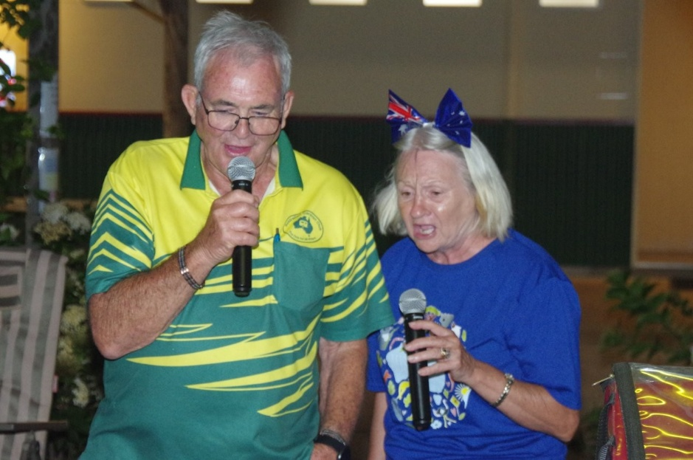
Karakoe night
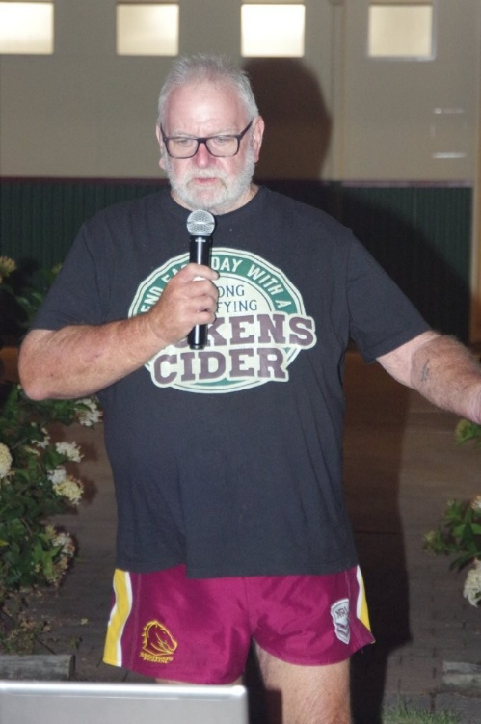
Karakoe night
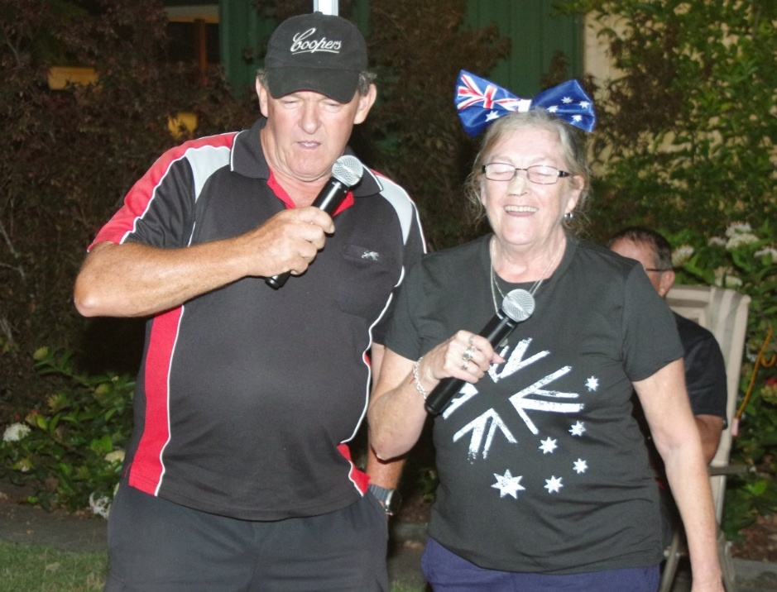
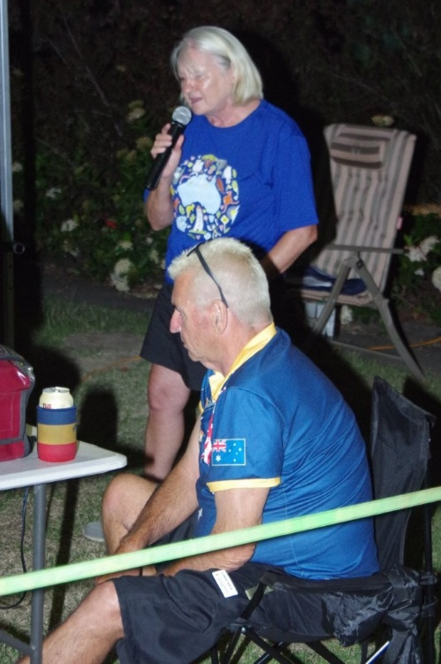
Great job, Cheryl, Perry and Wilko.
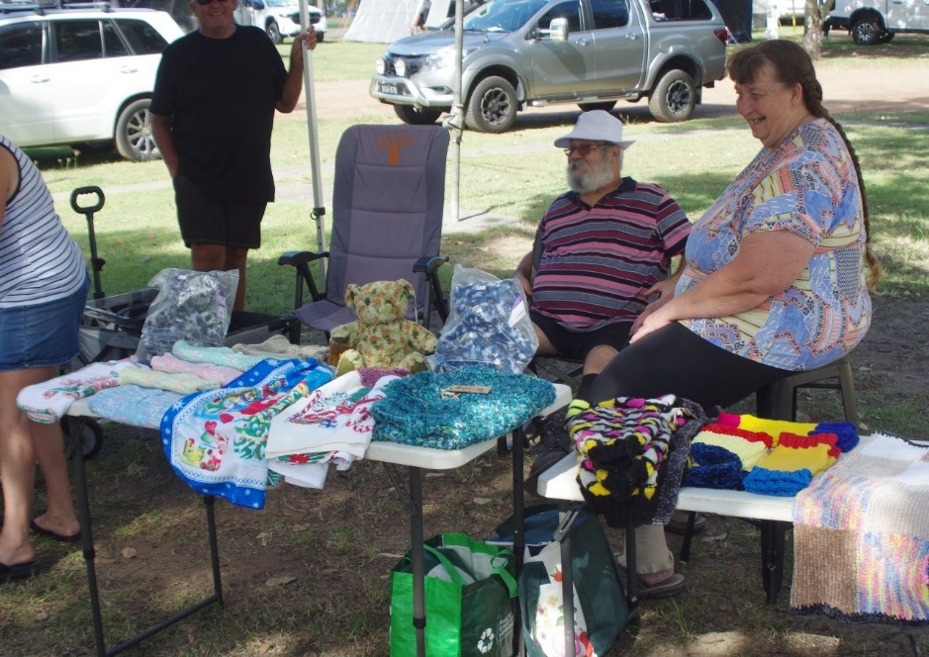
The Craft Markets
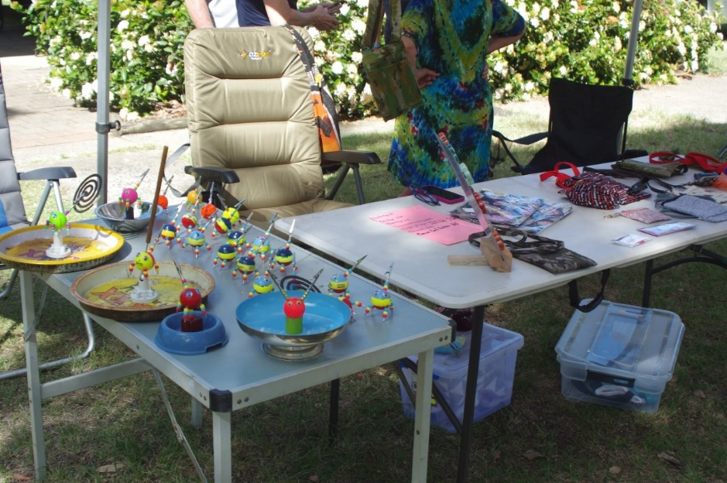
The Craft Markets
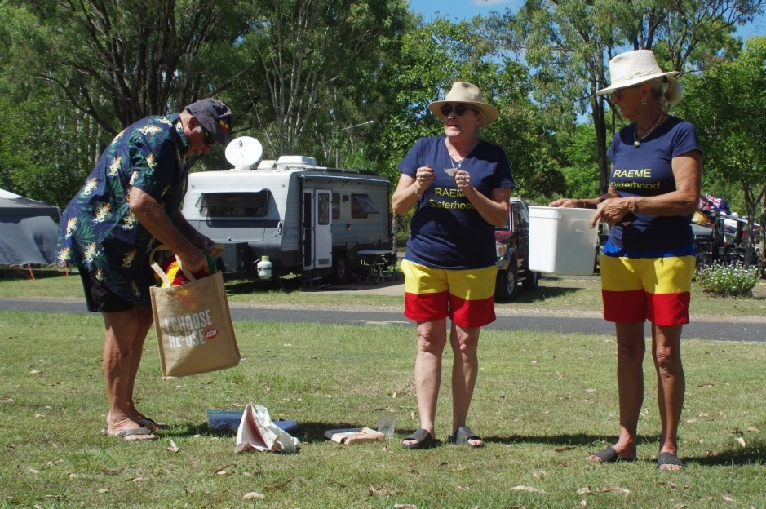
Drawing the major raffle prize.
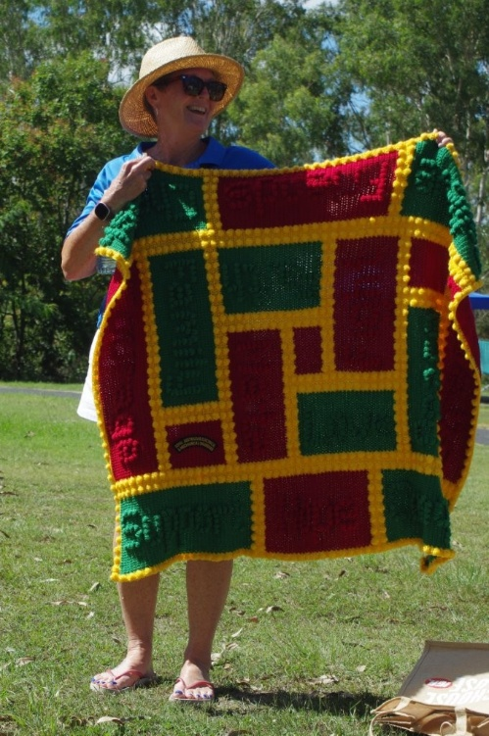
And the winner is…
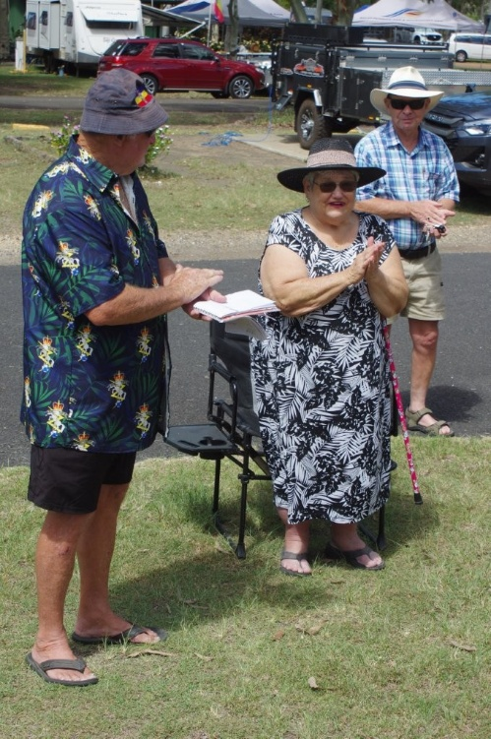
Presenting $5223.23 to the President of the Murgon Hospital Auxiliary.
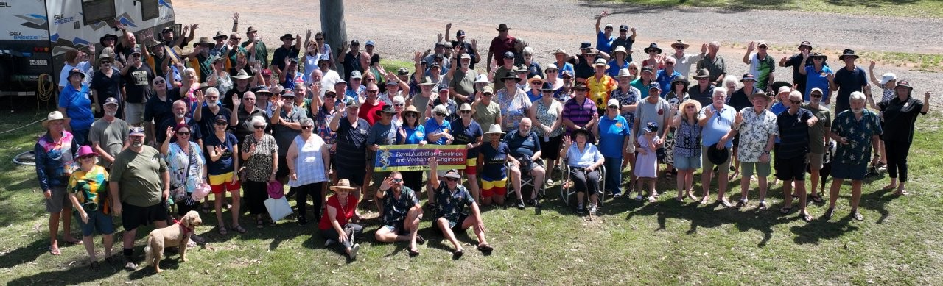
The “Gathering”

