MISFIT RACING

PROMOD Camaro

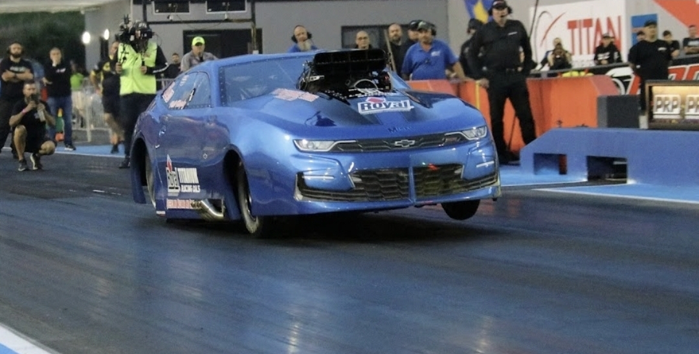

Sponsorship Proposal 2026

Neil Murphy 0417 175 167
Pm4140@outlook.com

ABOUT US

OWNER DRIVER Neil Murphy is a family man of 4 children with spouse Michelle, residing in Burpengary East, QLD. Neil has served 30 plus years in the Australian Army with numerous overseas deployments over this time. Now retired from a distinguished full-time career, he now holds a full-time position within civil support to Defence and still serves with the Australian Army Reserves when required.

Neil has been involved in drag racing since as early as 15 years of age at Willowbank Raceway here in QLD. His very first taste of racing was with his XB 6 Cyl Falcon, capable of 15 second 1/4 miles. The following decades generated a vast collection of cars including Ford Capri, EA Falcon chassis cars and numerous Mustang Full Chassis cars, both blown and aspirated configurations, all the way his current 2023 Bodied Jerry Bickel Chassis PRO MOD Camaro. All of which have been hand built or finished personally in shop.

Currently operating as a “privateer” in IHRA Group 1 PRO MOD, Neil and the team have remained competitive against the well-funded, branded and sponsored vehicles within this National Class. Currently (2026) the team sits 5th in the Australian Championship.

Our team is deeply connected to the Defence community, with 75% of our crew either having served in the Australian Defence Force or having a family member currently serving or who has previously served. This strong connection brings a shared commitment, discipline, and team-focused mentality to everything we do.

We are extremely passionate about championship drag racing, both domestically and internationally. The extensive experience and dedication of our long-term volunteer crew members drive us to continually achieve personal and team milestones while maintaining a competitive edge on the track. This creates a positive, enjoyable, and supportive environment where challenges are embraced, solutions are found, and no obstacle is too great in the demanding world of Group 1 drag racing.

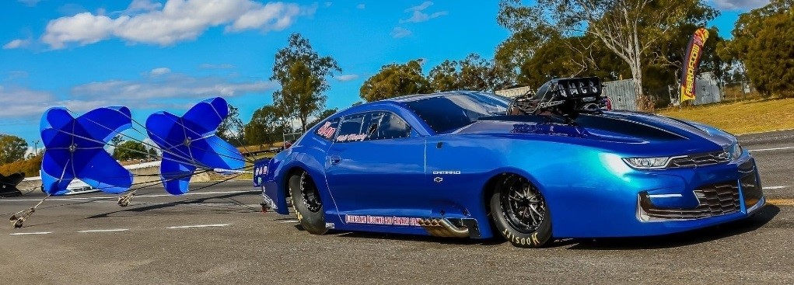
The Race Car

2023 Bodied Chevrolet Camaro Pro Mod

- Latest design Jerry Bickel Blown 4 link Pro Mod Chassis
- Strange front struts, JBR Rear Shock
- 5 Star Race Car Bodies Fibre Glass Race body
- Latest Fuel Tech engine and vehicle management system
- 521ci BAE (Brad Anderson Engineering) short engine
- Noonan MACH1 heads
- PSI 206D Screw Supercharger
- Manton valve train, JE Pistons, GRP Rods
- Rossler Turbo 3 TH400 Transmission (Non Lockup)
- Neal Chance converter
- Strange Modular rear differential
- Weld Racing Bead lock rims on Hoosier Slicks

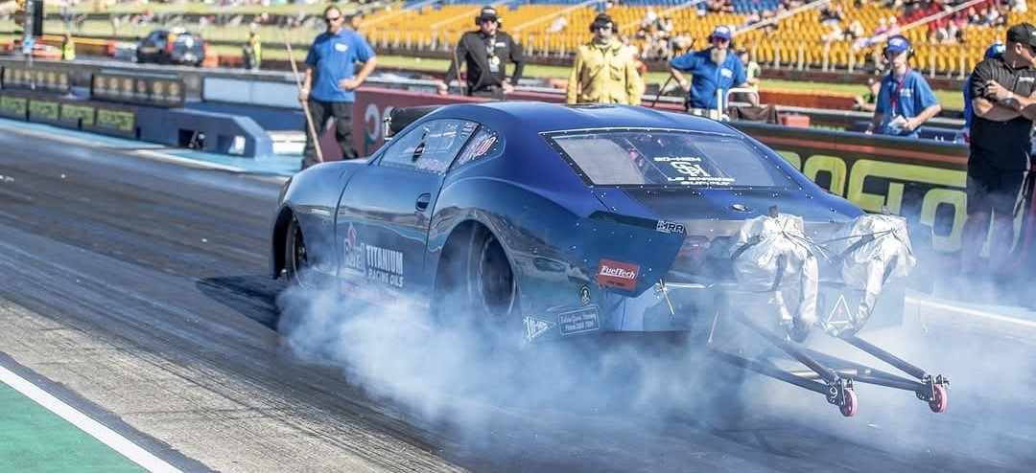

With the current state of the art build spec on our 2023 Camaro, has it poised to be highly competitive given the appropriate funding. The current value of the car itself sits at $375,000 AUD which is a huge undertaking by Neil & Michelle with no finance or sponsored backing.

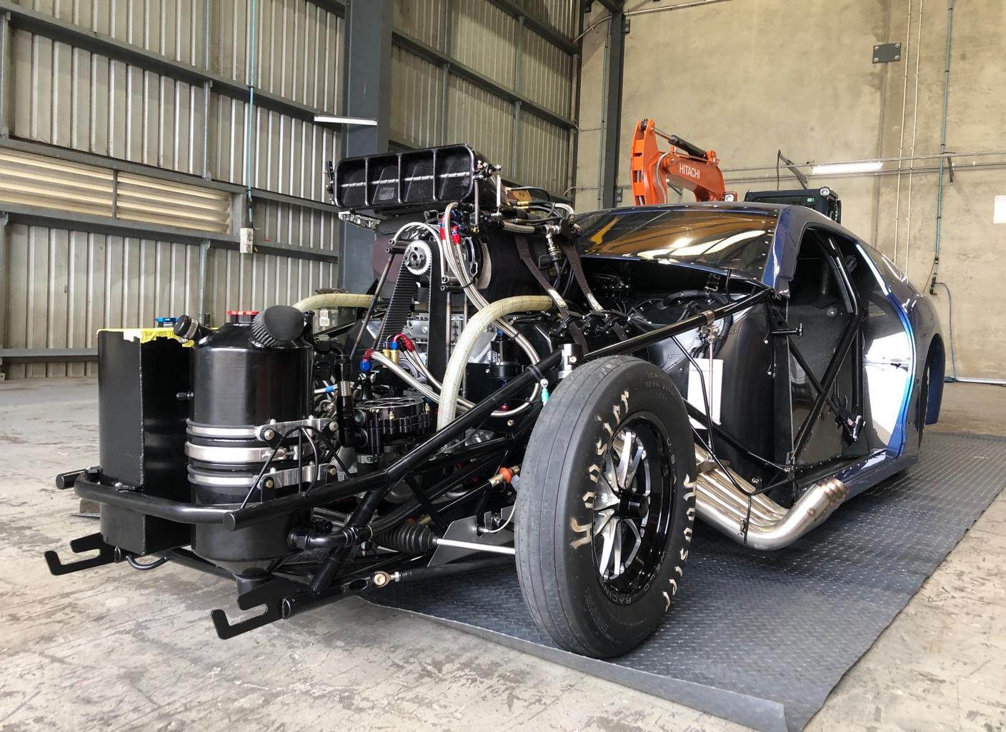

The team holds an extensive backup of critical spare parts to keep the car on track at any major event no matter where we race in the country.

PERFORMANCE AND GOALS

Currently the car has proven to be very competitive with conservative tuning in our 5.85 et Indexed class. With regular 5.85’s elapsed times and a PB of 5.69 @ 258MPH! The car and team continue to qualify and finish in the top 5 at all meets and are determined for Q1 and 1st place finishes with a strong focus toward an Australian Championship with the appropriate funding.

PB run break down:-
60 FT- .940
660 FT- 3.76 328 kph
1000 FT- 4.81
1320 FT- 5.69 415 kph
The car is completing the 100 metres in .88 sec

EXPOSURE

The opportunity to now race in Group 1 Australian Drag Racing brings a professional commitment to ourselves and future business partners. Regular global and domestic appearances on Kayo, Fox Sports and at track interviews with promotional vision along with the best presented Camaro ProMod in the country generate immense interest in our programme.

Social media plays an important part of the reach to our fans with regular round to round and qualifying live updates. We admire the social interaction this gives Neil and the team as we are always willing to share the car with fans, talk and listen to what our car means to them.

Our 2023 Camaro ProMod is a major draw card at major race events, business promotion open days, and car shows. It is a perfect opportunity to share our passion for the sport with both the novice and experienced race fan, especially our start-ups! We are always looking for the next opportunity to promote our sport and race car.

On track, the sound and appearance of our race car draw natural attention and present a perfect opportunity for prospective business exposure. Our Race team tows to local and interstate tracks with professional looking 2021 Chevrolet Silverado 1500, soon to arrive 2022 Chevrolet 2500HD hauler and clean skin enclosed vehicle trailer for added promotional opportunities.

MARKETING OPPORTUNITIES

Any prospective partner doesn’t need to be told how expensive this amazing sport can be, even without racing breakages. The performance requirements of Group 1, and the amount of racing and performance we compete at does come at a cost.
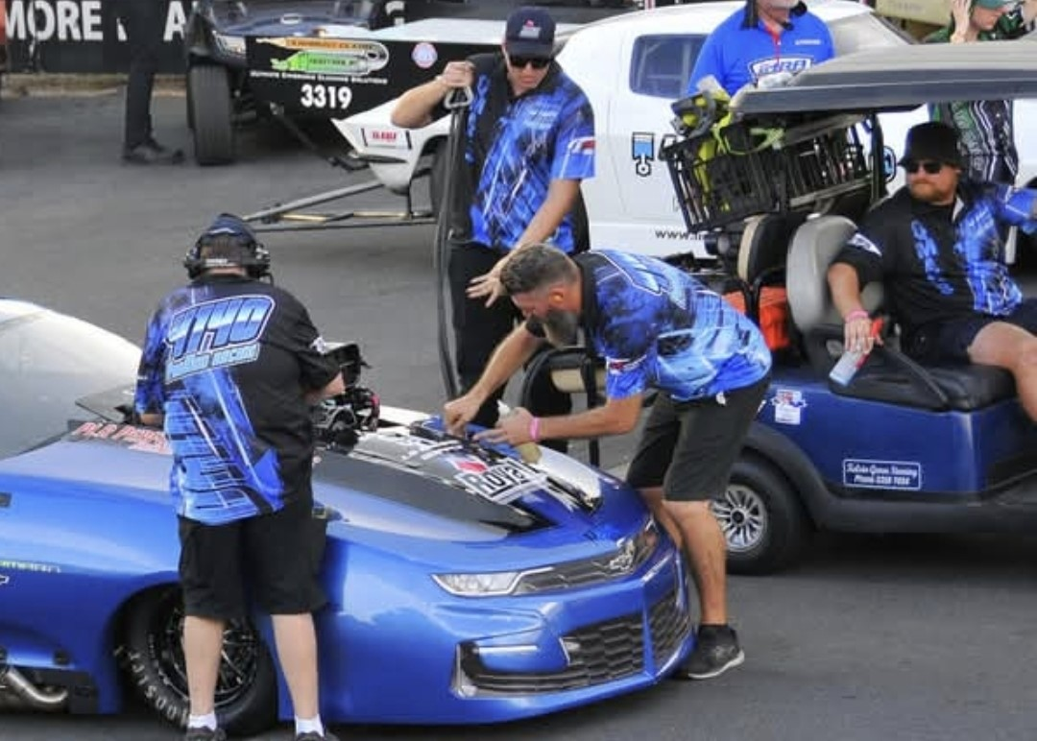
Currently the team has an average cost per race meet of $7750.00-$9950.00 depending on location. A usual race meet will consist of 3 Qualifying rounds, and 3-4 Racing rounds depending on class size for the event.
This per event costing takes into consideration:
- Towing, Travel and Event Entry fees;
- Fuels, Oils, Spark Plugs and Pit Consumables;
- Wear and tear on engine and driveline calculated as a life span consumable plus between meet preventative maintenance; and
- Crew hospitality.

A usual racing season consists of 6-10 major meets of IHRA and any major events across the Eastern Seaboard. We also have a strong willingness to race at the newly opening facility at the Bend in SA in the future.
Entry to Western Australian events at Perth Motorplex would be a sponsor negotiated event only due to added costs incurred.

Add-on events that we currently race at Willowbank Raceway and wish to expand into are the Jamboree Sport Compact and Drag Racing spectaculars in Melbourne and Sydney.

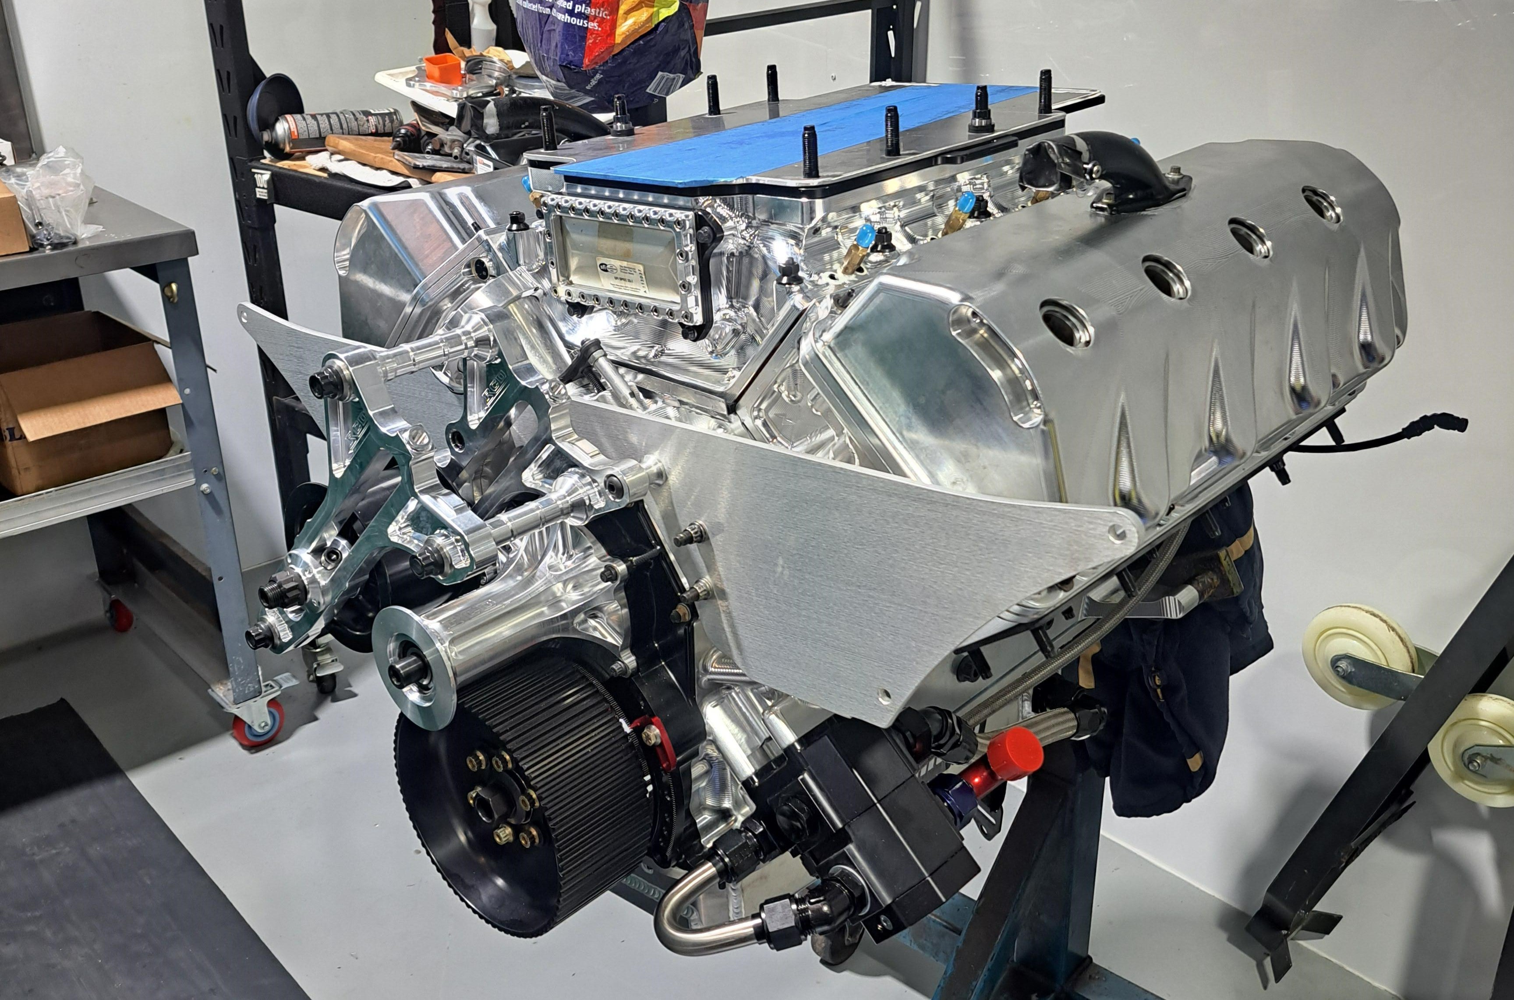

OPPORTUNITY

We offer a 4 Tier marketing opportunity to be a part of MISFIT 4140 Drag Racing.

- Associate partner programme
- Silver Partner
- Gold Partner
- Platinum VIP

Associate Partner Programme
- Items, parts or services are supplied by the prospective partner required for racing. These requirements are parts or services manufactured by the partner but may consist of financial invoices covered by the partner in agreement.
- Please enquire for individual costings. In-kind offerings are a negotiated per offering basis.
- In-kind partners receive the opportunity to advertise on the car and transport trailer. Two logos per car and 2 per trailer up to 30x20cm decal in size for 12 months.
- Sponsor credited on event social media posts.
- Transport and logistics support.
- Price negotiated on sponsorship enquiry.

Silver Partner Single Event

- Social and TV media mentions and gratitude
- Track interview mentions and gratitude
- 150 Branded stickers/handouts for fans
- Sponsor product display at pit area
- Rear wing advertising both sides of car
- 2 Event entry tickets and team T-Shirts

Gold Partner Per Annum

- Social and TV media mentions and gratitude
- Track interview mentions and gratitude
- 150 Branded stickers/handouts for fans per event
- Sponsor product display at pit area
- Pit crew shirt brand inclusion (these items are also sold at all events and online)
- Lower door advertising on both sides of race car and Transport trailers.
- 1 Static Display per annum at Company site or function
- 4 Event Tickets and T-Shirts for attendees per Entered race meeting
- Price negotiated on sponsorship enquiry

Platinum VIP per Annum

- Major naming rights sponsor partner
- Prominent branding of vehicle and transporters
- TV and Social Media gratitude and mentions
- Track interview acknowledgement and gratitude
- Pit Advertising banners
- Pit area product displays
- Crew Pit T-Shirt advertising
- Start line uniform major branding
- Start line banners on support vehicle
- Track support vehicle branding
- Local static (negotiable) vehicle displays at company stores, sites or functions including 2 car start-ups per annum
- Free branded stickers and fan cards
- 4 Event Tickets per Entered Event
- Logos on all merchandise available at track and online
- Extra events such as Jamboree Included
- Price negotiated on sponsorship enquiry

We thank you for your interest in our Drag Racing Programme! Please contact Neil Murphy for any further information or opportunities you may require.

We look forward to making your brand stand out from the rest!

Neil Murphy

Mobile: 0417 175 167
Pm4140@outlook.com
