BIRD DOG CREW CHIEFS - 161 (INDEP) RECCE FLT WKSP SVN 1967-68
Little is known about the exploits of four RAEME technicians, who served with 161 (Indep) Recce Flt Wksp in SVN in 1967-68, who were given training as Crew Chiefs to better support Australian Cessna 180 aircraft, then in service in SVN from 28 August 1967 to 15 March 1968. These men received training at the US Army’s 184th Reconnaissance Aircraft Company (RAC) based at Phu Loi over 4 weeks before being qualified as Bird Dog Crew Chiefs.
Bird Dog Crew Chief training was informative and straight forward as the aircraft technicians were already trained on the unit Cessna 180’s. The training involved pre-flight and after flight servicings, ground starts and routine day to day maintenance of the Bird Dog, or Cessna 0-1A aircraft, to give the aircraft its correct name.
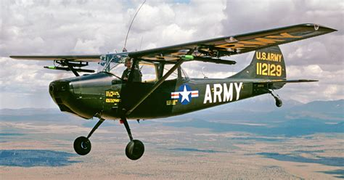
Cessna 0-1A
The Bird Dog was a remarkably similar aircraft to the Cessna 180, being fitted with a Continental 6-cylinder engine, two magnetos, a carburettor and a simpler propellor system with a fixed pitch. The Bird Dog engine cowling design made access to the engine quite easy and Bird Dog maintenance was similar to the Cessna 180’s. American mechanics were authorised to taxi Bird Dogs around the maintenance area and Corporal Manfield and Craftsman Watson also qualified to taxi the Bird Dogs.
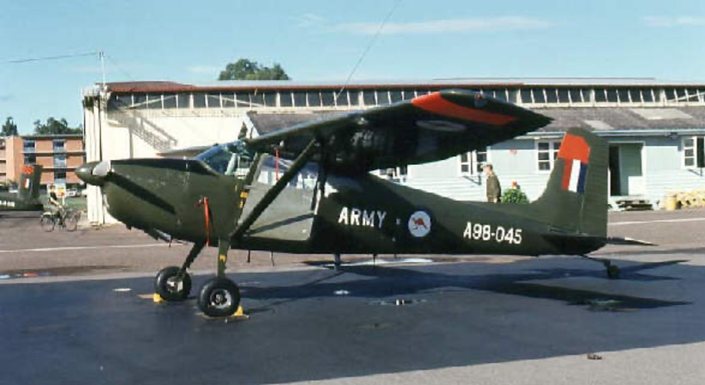
Australian Cessna 180
The four aircraft technicians who qualified as Bird Dog Crew Chiefs were as follows:
- Corporal Robert James JONES. “Jim”, as he was better known, served in SVN from 8 April 1967 to 12 March 1968 with 161 (Indep) Recce Flt as an aircraft engine fitter. He graduated from the Australian Army Apprentices School as a 13th Intake Vehicle Mechanic. He transferred to 16 Army Light Aircraft Squadron in early 1966 and completed the 2nd Aircraft Engine Fitters Course. In early August 1967 he became the first Bird Dog Crew Chief to be trained at Phu Loi. Jim passed away on 26 March 2017.
- Corporal David Harry SHEARER. “Clipper”, he was known, served in SVN from 14 June 1967 to 10 September 1968 with 161 (Indep) Recce Flt as an airframe fitter. He graduated from the Australian Army Apprentice School as a 17th Intake Fitter and Turner. He transferred to 16 Army Light Aircraft Squadron in January 1966 and completed the 3rd Airframe Fitters Course. In November 1967 he became the second Bird Dog Crew Chief to be trained at Phu Loi. Clipper now lives in Brisbane, after a long and successful career with the Australian Maritime Service Authority.
- Corporal David Michael MANFIELD. “Speedy”, as he was better known, served in SVN from 17 January 1968 to 26 November 1968 with 161 (Indep) Recce Flt as an airframe fitter. He graduated from the Australian Army Apprentice School as a 17th Intake Fitter and Turner. He transferred to 16 Army Light Aircraft Squadron in January 1966 and completed the 3rd Airframe Fitters Course. Speedy now lives in Sydney after a successful and long career in the Queensland Police Service.
- Craftsman Philip WATSON. Phil served in SVN from 18 December 1967 to 17 December 1968 and from 6 February 1971 to 7 February 1972 with 161 (Indep) Recce Flt as an aircraft engine fitter. He graduated from the Australian Army Apprentice School as a 18th Intake Vehicle Mechanic. He transferred to 1 Division Army Aviation Regiment Workshops in December 1966 and completed the Engine Fitters Course. Phil now lives in Cairns after rising to the rank of WO1 ART ACFT and has kept busy as an DVA Advocate.
184TH RECONNAISSANCE AIRCRAFT COMPANY – PHU LOI
Phu Loi Army Airfield was located north-west of Bien Hoa in Binh Duong Province and about twenty-two kilometres north of Saigon on Route 13. The 184th RAC compound was located at the south-east corner of the base. Major units of the North Vietnamese Army (NVA) and Viet Cong (VC) troops used the area around Phu Loi for pre-TET offensive staging and as a jumping-off point for attacks on Saigon and surrounding U.S. and South Vietnamese Installations. Because of increased ground attacks on the base, the 184th RAC was tasked with building and manning night defensive positions. Over fifty per cent of the company’s strength was committed to this task. To protect the aircraft in the event the enemy did penetrate the perimeter, three machine gun positions were set up on the flight line and the guard was doubled at night. The 184th RAC had 24 Bird Dogs, 28 officers and pilots and 122 enlisted men.
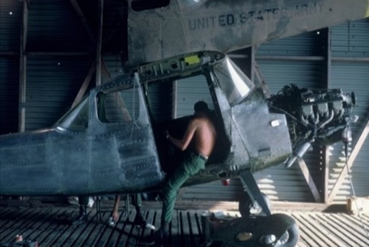
Bird Dog undergoing major service at 184th RAC
During Dave Shearer’s time there, he experienced numerous night rocket attacks. Early one morning he was woken by a rocket attack and went to nearby bunker which he found was already full of American soldiers. So he sat in the bunker doorway with his hands over his head, hoping nothing would land near him. On another night the 184th RAC received incoming rockets and a rocket exploded close to one of the Bird Dog aircraft spraying the full length of the portside fuselage and main frame with shrapnel. The aircraft was written off.
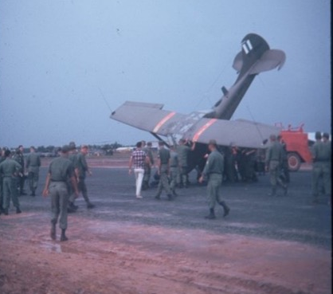
Damaged Bird Dog which crash landed at 184th RAC
During the time Speedy Manfield and Phil Watson trained at Phu Loi, the base was subjected to continuous nightly rocket attacks and sporadic grounds assaults. In their first 5 days, the base was subjected to seven separate heavy rocket attacks. The conditions were primitive for all who served in Phi Loi, and during the 1968 TET 1968 offensive several 184TH RAC personnel were wounded whilst sleeping in huts with wooden floors and sand only bagged walls. Several bunkers positioned around the 184th RAC were above ground structures like Quonset huts but smaller huts were made from corrugated iron with sandbags on top. It certainly did not inspire confidence regarding protection as a direct hit would have destroyed the bunker.
Early on the morning of the 18 February 1968 at 0045, five rockets were fired towards the Phu Loi base camp. Two rounds scored direct hits on the maintenance hangar starting a fire that threatened to destroy the building, ground support equipment and two workshop vans which contained the tools and machinery. The mess hall also scored a direct rocket hit and was severely damaged and three Bird Dog aircraft sustained severe damage.
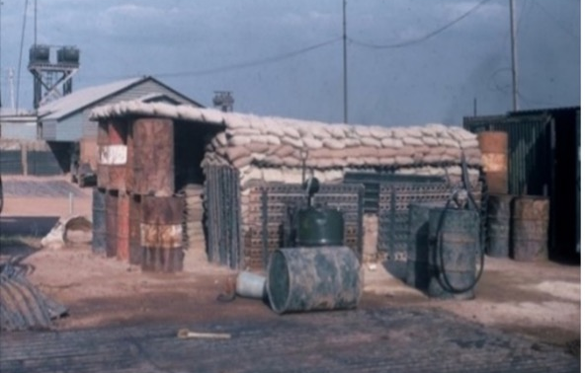
Bunker at 184th RAC at Phuc Loi
Craftsman Watson received his only war wound (a scar on his elbow) when he dived onto a concrete floor when he heard an incoming rocket coming in which was the second attack on the first night. Corporal Manfield and Craftsman Watson were not impressed with the bunkers they had been allocated which were used by most of the maintenance crews. On one night rocket attacks the 184th RAC orderly room was damaged, causing paper work to be showered over the entire maintenance area – other damage included a Bird Dog which was written-off after receiving 275 shrapnel holes.
On one morning the VC, or NVA, launched a ground attack at the main gate and Corporal Manfield and Craftsman Watson raced down to the main gate to try get involved in the fire fight. They were ordered to go to a nearby bunker where they remained for about one hour until the ground attack was defeated. On another night Corporal Manfield and Craftsman Watson occupied a perimeter bunker and observed the nervous perimeter guards calling for flares to light up an area in front of the bunker which included a cemetery with the Phu Loi township about five hundred metres in the background.
Overall, Corporal Manfield and Craftsman Watson enjoyed their time at the 184th RAC and worked on the Bird Dog aircraft in a big carport type shelter which was shaded from the sun but not from any sideways rain.
Excerpts from Dave Manfield’s story entitled: “Bird Dog Crew Chiefs – 161 (Indep) Recce Flt”, dated 3 Feb 26.

